Developing Internet based Information Systems 2

HW4

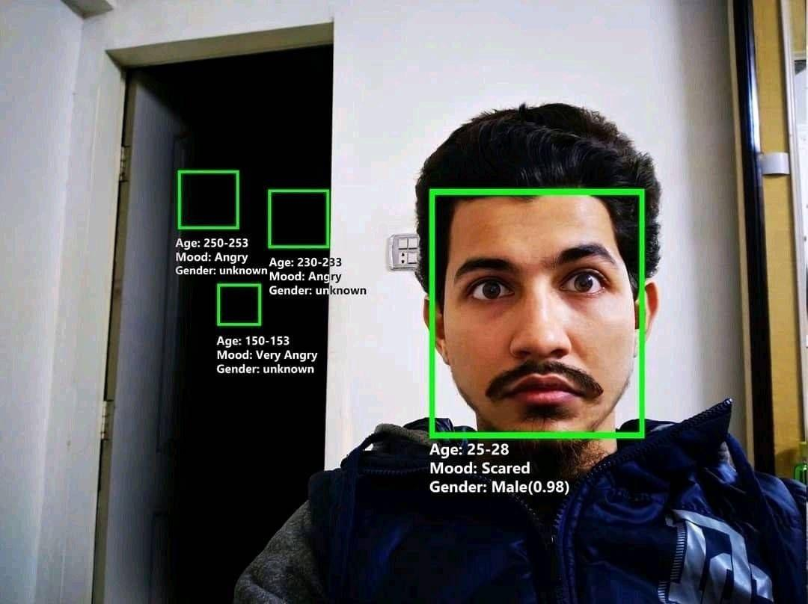

This HW exercise is based on the third HW exercise and its goal is to practice working with a data table to create an admin view page and the topic of Ad-Hoc Objects.

**Database instructions: (work on test2 database)**

*Add a field called isActive to the user table and initialize it to true (1)

*Manually add an admin user: email admin@admin.com , password Admin1234

* Add a SP which accepts isActive and Id and updates the isActive field for a specific user.

**SP_UpdateUserIsActive**

* Add a SP which returns all users with the following information per each user: id, username, number of games they bought, the amount of money the user spent on the games, and the isActive field.

**GetUsersWithGameStats**

* Add a SP which returns all games with the following fields: id, title, number of downloads and total amount users paid for this game.

**GetGamesWithStats**

**Server-side instructions:**

*Add an isActive attribute to the user class

* Handle all methods for editing the isActive field for a specific user.
* Handle all methods to read the data which returns users with the specified information.
* Handle all methods to read the data which returns games with the specified information.

*Note that you will need to use Ad-Hoc objects.

*Note, you need to edit the login method so that only users who are isActive=true can log in, otherwise an exception should be thrown.

**Client-side instructions:**

* Add an appropriate message to a user which fails to login.
* Add adminPage.html, the link to this page should be in the home page accessible only to the admin user.
* On the admin page, add datatables to show the data according to the fields in the image below. Enable the admin to edit the Active Status.
* Add a switcher (can be a button) to switch between the 2 datatables.

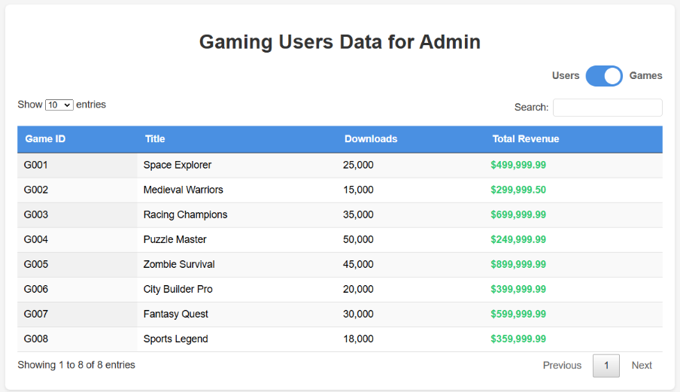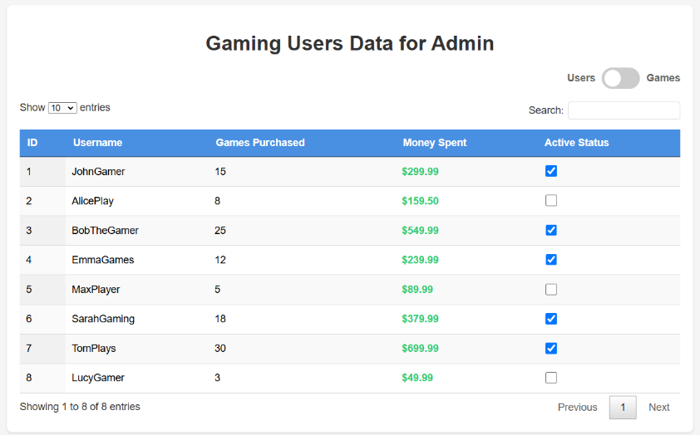

**Bonus**

Get creative and use an external hugging face API, adding an AI component and integrate it into your project. In case you choose to implement it, describe it in a bonus.html page linked to the main page. Surprise us , do not use the exact examples provided by us.

Good luck Benny & Gilad 😊